Pumps

II Stage Pumps
Model: | K30 | 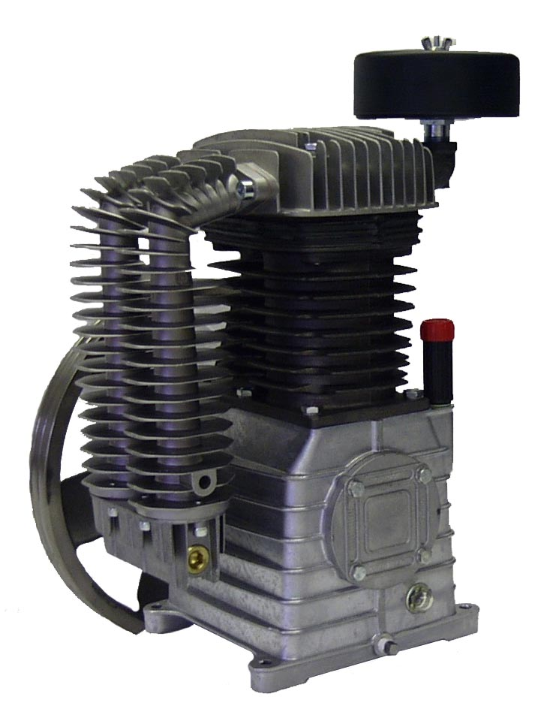
HP: | 5,7-1/2
RPM: | 800,1200
Piston Displacement: | 20.52,30.78
Max PSI: | N/A
ACFM at 175 PSI: | 16.01,23.63
ACFM at 100 PSI: | N/A
ACFM at 40 PSI: | N/A
Measurement A: | 7.48
Measurement B: | 5.31
Measurement C: | 8.97
Measurement D: | 14.17
Measurement E: | 16.33
Measurement F: | 22.24
Measurement H: | 18.70
Cylinders: | 2
Bore LP: | 4.13
Bore HP: | 2.05
Stroke: | 3.31
Flywheel Dia (Inches): | 15.16
V Belts: | 2-A
Dry Weight (Lbs): | 83.8
Intake (Inches): | .75
Discharge (Inches): | .75
Oil Capacity (Oz.): | 47
Special notes: | *Available with Constant Speed Head Unloaders.
View: Schematic

